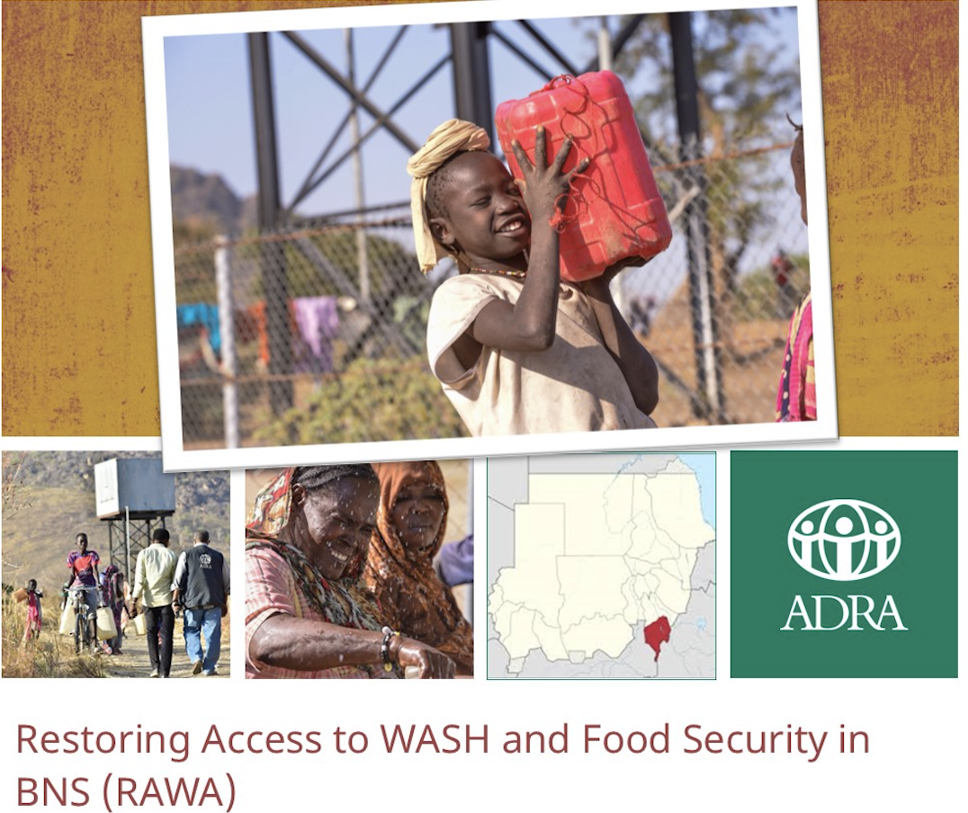

MID-TERM REVIEW/EVALUATION TERMS OF REFERENCE (TOR):

Summary

RAWA project would like to conduct a beneficiary midterm review which will be a probability proportion to size sample (PPS) in order to collect the midterm values of the project performance indicators and supplement where necessary, ADRA Sudan’s record of achievement of intended impact as defined by the project’s design and milestones.

Timeframe: 09-30 December 2022
Language of report: English
Language(s) of target area: Arabic, Phalata, Hamaj & Barta
Application submission: CV & cover letter to Programs@adrasudan.org

- Project & Organizational Background

The Restoring Access to WASH and Food security in BNS (RAWA) project (first phase September 2021 to September 2022) aimed to provide life-saving integrated interventions in Blue Nile State to address the protracted WASH, Health, Nutrition and Protection conditions faced by the population and alleviate the underlying food security issues by restoring livelihoods and agriculture cultivation.
The program activities are grounded in this development hypothesis and are focused squarely on the following three parallel “If” statements:
- IF RAWA rehabilitates critical water infrastructure such as hand pumps and hafir water systems; THEN, it will increase safe access to clean and safe water to people within the target communities.
- IF RAWA provides WASH NFIs kits to extremely vulnerable households; THEN, it will further mitigate the risks of transmissions of vector-borne diseases/water related diseases.
- IF RAWA provides hygiene promotion activities, education, and communication materials to the participants; THEN, the project participants will be better prepared to make the best use of water infrastructure.
- IF RAWA trains smallholder farmers on best practices aim to increase yield, provide agriculture inputs, in addition to strengthening their production capacity through farmer field schools; THEN, the project participants will be able to decrease their crop yield losses and enhance household level food security and income.
- If RAWA provides access to cash assistance for small businesses interrupted by conflict; THEN, vulnerable households will be able to increase their income resulting in improving their food security.
- IF RAWA supports damaged health facilities and provides primary healthcare services in the supported health facilities and their catchments; THEN, it will increase access to high-quality, life-sustaining, and life-saving health services among affected populations especially for women of childbearing age and children under five.
- IF RAWA increases the number of trained and equipped facility and community-based nutrition service providers and core nutrition activities to screen, refer and treat cases of severe or moderate malnutrition; THEN, rates of malnutrition-related risk of death will be reduced and rates of malnutrition cures will be increased for children under five years of age and pregnant and lactating women.
- IF RAWA’s mother-to-mother support groups are established; THEN optimal health and nutrition behaviors will be more consistently practiced amongst the community particularly among pregnant and lactating women (PLW) and children under two and the adverse effects of malnutrition on children’s mental and physical development and life-long learning capacity will be reduced.
Through RAWA program, ADRA planned to reach vulnerable food insecure and water scarce communities in Blue Nile State (BNS) — including IDPs and areas that haven’t received humanitarian assistance in years due to ongoing conflict—with critical life-saving WASH and food security and livelihoods (FSL) interventions designed to provide households with the access, knowledge, and tools necessary to increase their food security and decrease water-related disease. In Kurmuk and Bau, ADRA has taken a community-based approach to provide 22,254 people with access to water complementary hygiene promotion, and WASH NFI distributions to fully support health improvements, agricultural training and inputs—improved seeds and tools—they can use to improve their household subsistence and train others to do the same. (Improved seeds are those with high yield potentials, early maturity, better grain quality, and preference at market. ADRA provided improved varieties as recommended and adopted by the Ministry of Agriculture.)
These interventions were designed for 13 villages in the two localities of Kurmk (5 Villages) and Bau (8 Villages) in coordination with the WASH Sector to address chronic and acute WASH needs, food insecurity, and a lack of resources that has dragged these communities into crisis and emergency phases of food insecurity. After years of fighting and inaccessibility by humanitarian actors, there are huge gains in health and quality of life to be made by an organization with experience and access to the area. These interventions are especially important as the COVID-19 pandemic sweeps across the world, threatening food insecure countries with weak healthcare systems such as Sudan the most. Access to water and the information on how to use it safely is one of the most simple and powerful tools for mitigating the spread of this disease, and providing a path to subsistence farming is crucial as fears of a COVID-19-caused global food shortage circulate.
The chosen interventions have been designed after on-the-ground assessments and community consultation. They are designed specifically for their target communities, and they are designed to meet the most crucial needs. In addition to the WASH and agriculture related interventions, RAWA project has incorporated health and nutrition components in the extended phase of RAWA project (September 2022 – August 2023) that will be implemented by Medair. For the Health component, the RAWA project will cover three (3) villages in Bau locality and two localities Kurmuk (1 village) and Bau (4 villages) will be covered through Nutrition component.

Thus, although we have used the term midterm review for this assignment, for WASH and agriculture components it will be as a midterm whereas it will be a baseline for the Health and Nutrition components.

- Program Objectives
The RAWA project targeted a total 22,254 direct individuals. The project’s goal has been to Provide life-saving integrated interventions in Blue Nile State (BNS) to address the protracted WASH, Health, Nutrition and Protection conditions faced by the population and alleviate the underlying food security issues by restoring livelihoods and agriculture cultivation.
There project has two purposes:

- Purpose 1: To improve access to safe water sources and supply and hygiene practices at the household level, thus improving the overall health conditions of affected population.
- Purpose 2: To improve access to food supplies through increased access to agricultural inputs and resilient practices while also increasing household income from new and restored livelihoods.
- Purpose 3: To increase access to quality essential services and reduce excess morbidity through integrated health and nutrition services.

- EVALUATION PURPOSE

The overall objective of the midterm review is to explore learning from the project interventions, assess positive outcomes thus far achieved and recommendations for the next phase of the project. The following are the main purposes of the midterm review:

- To explore and capture the learning of the RAWA project and utilize the learning in the next phase of the project
- To explore to what extent the project’s purposes and goals—at all result levels—have been achieved and compare the indicators level achievements with the Baseline values.
- To assess the extent to which the different outcomes/benefits arising from the RAWA project are likely to continue after activities have been completed; and
- To access the impact of the project on the targeted groups and beneficiaries involved in the project.
- To assess the Seeds Security situation in the project target area and provide short, medium and long-term recommendations for action.
- To produce baseline values for the Health and Nutrition components.

- EVALUATION TYPE

The evaluation conducted will be a summative performance evaluation.
EVALUATION QUESTIONS

The Evaluation will focus on the following questions:
Table1: Evaluation Questions
Focus of evaluation | Evaluation Questions
Relevance | To what extent was the design of the project suitable in meeting the needs of beneficiaries and key stakeholders?  - To what extent did the project design meet target groups and beneficiary needs?
Efficiency | To what extent was the project implemented in an efficient manner?  - To what extent were the intended outputs delivered?
Effectiveness | To what extent has the project achieved its main objectives (expected results and impacts) in the different project components?  - To what degree were benefits of the program available to the intended target group and beneficiaries?  - To what degree was the program implemented as intended? If it wasn’t, why not?
Outcome | What results, expected and unexpected, and direct and indirect, were produced by the program?  - To what extent did the program achieve its intended changes?  - What are the appropriate agricultural techniques and conservation techniques most practiced by type of crop?
Sustainability | To what degree was there an indication of ongoing benefits attributable to the project?  - What factors contributed to or prevented the achievement of ongoing benefits?  - What evidence of sustainability is there that the adoption of agriculture techniques will continue after project ends?  - What evidence of sustainability is there that the adoption of hygiene practices will continue after project ends?
* Additional principles of evaluation in the context of humanitarian setting such as coherence, connectedness and coverage can also be considered for the midterm review.

- EVALUATION METHODS

The midterm review/evaluation will include mixed methods (both qualitative and quantitative) and will use different approaches to assess the effectiveness, efficiency, outcome, sustainability, and impact of the project. The same quantitative questionnaire and methodology used for the RAWA baseline survey will be used for the midterm review/evaluation. The baseline questionnaires should be modified to incorporate additional purposes of the midterm review and capture qualitative learning aspects of the project.
- For quantitative survey a sample will be drawn from the targeted group receiving activity support
- For qualitative approaches focus group discussions (FGD), Key Informant Interview (KII) and direct observations
The methods that will be used to capture the responses to the above evaluation questions will follow a participatory consultative, transparent, and interactive approach. It will include both qualitative and quantitative methods: field visits, direct observations, and interviews with external (beneficiaries, key government departments, and local partners) and internal stakeholders, e.g., project staff. In addition, it will include a desk review of the project documents and reports.

* The same quantitative and qualitative approaches are going to be conducted to have a baseline date for the Health & Nutrition sectors.

* For Seeds Security Assessment (SSA), it is recommended to use both qualitative and quantitative data collection tools such as key informant interviews, focus group discussions and sampled household and local market surveys.

- Sampling Framework

The targeted sample size of the midterm review/evaluation will include both male and female headed households including child headed and persons living with disabilities drawn from the communities where RAWA is being implemented. This will be done using a statistically significant sample of project beneficiaries and will be guided by the midterm evaluation sampling frame for realistic and representative comparisons between the two studies.

For the quantitative data collection, a household survey will be used using a statistically representative sample of program participants using the confidence interval level of 95% and a margin of error of 5%. Furthermore, to solve the problem of “no answer” the size of the sample will be increased by at least 10% or a percentage suggested by the consultant.

For qualitative data, purposive sampling should be used. The consultant should include the qualitative methods to be used, the method of key informant’s selection and the sample size indicating the formula used.

The sampling methodology of baseline will be shared with the selected firm/consultant; however, the applicant is expected to include proposed sample methods along with sampling size for this assignment and will be finalized upon mutual consultation.

- EVALUATION TIMELINE
The midterm review/evaluation will be carried out in December 2022 for a duration of approximately 21 calendar days.

- EVALUATION FINDINGS DISSEMINATION

ADRA will share the final results of the evaluation with local leaders and stakeholders at project closure or at a community forum. ADRA will also disseminate the results of the midterm review/evaluation with ADRA HQ and international NGOs and local NGOs.

- Key Indicators to be Collected

Sector | Subsector | BHA Indicator # | Indicators | Disaggregation
Purpose 1: To improve access to safe water sources and supply and hygiene practices at the household level, thus improving the overall health conditions of affected population
Intermediate Outcome 1.1: Increased access to improved water sources, and improved hygiene, and sanitation practices
WASH | Hygiene Promotion | W10 | Percent of people targeted by the hygiene promotion programs who know at least three (3) of the five (5) critical times to wash hands | Male/Female
WASH | Hygiene Promotion | W11 | Percent of households targeted by the hygiene promotion activity who store their drinking water safely in clean containers. | N/A
WASH | Hygiene Promotion | W8 | Percent of households with soap and water at a designated handwashing on premises | Gendered HH Type (Male and Female, Female No Male, Male No Female, Child No Adult)
WASH | Water Supply | W33 | Percent of households targeted by WASH programming that are collecting all water for drinking, cooking and hygiene from improved water sources | N/A
WASH | Water Supply | W40 | Percent of water points developed, repaired, or rehabilitated that are clean and protected from contamination. | N/A
WASH | Water Supply | W35 | Percent of households whose drinking water supplies have a free residual chlorine (FRC) > 0.2 mg/L | N/A
Purpose 2: To improve access to food supplies through increased access to agricultural inputs and resilient practices while also increasing household income from new and restored livelihoods
Intermediate Outcome 2.1: Increased access to nutritious food through new and restored agricultural livelihoods
Agriculture | Improving Agricultural Production | A4 | Number of beneficiaries households using improved post-harvest storage practices | Gendered HH Type (Male and Female, Female No Male, Male No Female, Child No Adult)
Agriculture | Pests and Pesticides | A10 | Number and percent of hectares protected against disease or pest attacks | N/A
Agriculture | Improving Agricultural Production | A2 | Number of hectares under improved management practices or technologies with BHA assistance | N/A
Agriculture | Improving Agricultural Production | A5 | Percentage of households with access to sufficient seed to plant | Gendered HH Type (Male and Female, Female No Male, Male No Female, Child No Adult)
Agriculture | Pests and Pesticides | A12 | Percent of individuals who received training that are practicing appropriate crop protection procedures | Male/Female
Economic Recovery and Market Systems | Livelihoods Development | E2 | Percentage of beneficiaries reporting net income from their livelihood | Male/Female
Purpose 3: To increase access to quality essential services and reduce excess morbidity through integrated health and nutrition services.
Health | Basic Primary Health Care | H7 | Number and percent of deliveries attended by a skilled attendant | Type of birth attendant: Midwives, doctors, nurses with midwifery and life-saving skills Location of delivery: Health facility, home, other
Health | Basic Primary Health Care | H8 | Number and percent of pregnant women who have attended at least two complete antenatal clinics | N/A
Health | Basic Primary Health Care | H9 | Number and percent of newborns that receive postnatal care within three days delivery | Male/Female
Health |  | C04  (Custom) | Number and percent of community members who can recall target health messages | N/A
Nutrition | MIYCN-E | N8 | Percent of infants 0-5 months of age who are fed exclusively with breast milk | Male/Female
Nutrition | MIYCN-E | N9 | Percent of children 6–23 months of age who receive foods from 5 or more food groups | Male/Female
*For Health & Nutrition the consultant is requested to provide baseline data against the indicators which are stated under Purpose 3.

The independent evaluation seeks to answer all the elements of the Terms of Reference (ToR); provide findings and conclusions that are based on thorough and transparent evidence and where necessary supplement the project data with independent research. The consultant will be provided with relevant program documents, including:
- List of Program Indicators
- Program MEAL Plan
- Implementation Area Map
- Program Proposal
- Survey questionnaire
- Knowledge, Practice and Covering (KPC) survey questionnaire.

- The Evaluation Team Composition

It is anticipated that this evaluation will require two weeks of field work with another 2 weeks of drafting and finalizing the report – a total of 20 working days. Interested applicants should submit their application for this consultancy in an envelope to ADRA Sudan Office in Khartoum with the mention “RAWA CONSULTANCY'' or send the application to email address (programs@adrasudan.org) not later than 8 December 2022. The application should include:
- A detailed technical proposal and a budget in USD. The budget must cover all consultant fees (e.g. travel to BN and accommodation).
- An updated copy of their CV including references and their contact details – no more than 4 pages.

*Only shortlisted candidates will be contacted.

The following competencies are ideal:
- Post-graduate degree in Development Studies, Monitoring and Evaluation, WASH, Agriculture, Health & Nutrition or any applicable social sciences field.
- S/he should have at least five years senior level experience in conducting evaluations of similar programs in a developing country context.
- S/he should have at least 3 years’ experience in conducting Endline surveys for NGOs in the WASH, Food security, nutrition, and livelihood sectors.
- Experience in leading and organizing evaluation teams.
- S/he should have extensive experience in conducting qualitative and quantitative evaluations/assessments and be familiar with the non-profit sector.
- Experience in analyzing survey data.
- Excellent oral and written skills are required.

Remuneration

Payment will be in phases as follows:
- 30% of the contract sum will be paid at the start of the consultancy.
- 30% of the contract sum will be paid upon completion and submission of the first draft report.
- 40% of the contract sum will be paid upon submission and acceptance of the final
Roles and Responsibilities

# | Tasks | Responsible
1 | Design and translation of the survey questionnaire |  | Consultant
2 | Creating the questionnaire in Kobo toolbox | ADRA Sudan
3 | Review of the Questionnaire | ADRA Sudan
4 | Design and Translation of the FDGs guide |  | Consultant
5 | Review the FDGs guide | ADRA Sudan
6 | Design & Translation of SSA with BHA guidance |  | Consultant
7 | Review the Seeds Security Assessment (SSA) | ADRA Sudan
8 | Design & Translation of KPC |  | Consultant
9 | Review of KPC | Medair
10 | Facilitating the FGDs |  | Consultant
11 | Determine the sample Size | ADRA Sudan
12 | Hiring the Enumerator | ADRA Sudan
13 | Training of Enumerator | ADRA Sudan | Consultant
14 | Supervising the data collection |  | Consultant
15 | Cleaning the Survey dataset |  | Consultant
16 | Report writing |  | Consultant

- Work Plan and Tentative Calendar

The midterm review/evaluation will be conducted and compiled from 9 – 30 December 2022. During this time the consultant can familiarize themselves with the project at their discretion. The table below shows the proposed calendar of activities.

Task | Days | Starting date
Reviewing project documents and designing of tools and field work plan in addition to setting up questionnaire contents in the server for data collection (Kobo toolbox) and producing inception report | 3 | 10-12/12/2022
Field work (Debriefing and collection of data)  - One day travel to Blue Nile state and setting up mobile phones for data collection.  - Two days for debriefing on work plan and discussing the plan of work in addition to training and orientating of enumerators  - Five days for data collection (FGD and partners) | 5 | 13-17 /12/2022
Data analysis and interpretation | 2 | 18-19/12/2022
Writing and submission of the 1st draft (Submission on 23rd) | 4 | 20-23/12/2022
ADRA Sudan and ADRA I revision (Send comment on 27th) | 4 | 24-27/12/2022
Consultant to address comments | 2 | 28 – 29/12/2022
Submission of final report to ADRA I | 1 | 30/12/2022
Total | 21

6. Logistics and Reporting

6.1 Reporting relations
ADRA Sudan is responsible for the recruitment and briefing to the midterm review/evaluation external evaluator(s) and will be the point of contact for the duration of the evaluation process. The consultant will report to the Project Manager with technical guidance from the MEAL Manager

6.2 Logistics and administrative support
The consultant should state what logistical and administrative support s/he will provide and what support s/he will require from the program´s structure after considering recommendations to mitigate spread of Covid-19.

The evaluation team will strictly adhere to wearing of masks, social distancing and washing of hands or use of sanitizers at all times. Interviews are conducted outdoors.

6.3 Deliverables

The consultants will submit the following reports all written in English:
- Inception Report with draft/finalized data collection tools
- Final evaluation report (about 20-25 pages without annexes)
- An electronic Dataset (raw data, output tables and syntax),

7. Communication and confidentiality
The consultant will report to the Programs Director with technical guidance from the MEAL Manager. ADRA will also provide logistical and technical support to facilitate required meetings and interviews, as may be required. To ensure a smooth and efficient process and enhance the learning from this evaluation, the evaluation team should place emphasis on transparent and open communication with key stakeholders.

ADRA considers it unethical for any member of Consultancy to use information gathered from Endline for anything other than the program under review. Should viable reason present itself for using the information obtained for other purposes, then, ADRA must be consulted, and prior permission secured. This must be adhered to, especially when the material is of a controversial nature and exclusively involves the private lives of the target population. To comply with the recent FFPIB 02-11 requirements, ADRA will provide clean data sets to USAID.

8. Distribution of Survey Report
The ultimate responsibility for gathering and disseminating information from all its USAID-funded programs around the world lies within ADRA International. Therefore, ADRA International expects the survey team, particularly hired consultant, to turnover to ADRA International all the data and other information that were used as the basis of the team's final inferences. It is ADRA's position that the assignment is not final until it is: 1) presented to ADRA, 2) both the consultant and ADRA have discussed the contents in an open manner and 3) clear understandings of all conclusions and any differing views are reached between the consultant and ADRA as reflected in the final document. ADRA does not edit or change in any form or fashion the final report of the team without the Team’s consent. In the event the team and ADRA remain to have a difference of opinion regarding the final report of the Endline study, ADRA distributes the document intact but will attach a letter to the report stating its own position.

9. Report Structure

Midterm review/evaluation report will be written in English and adhere to the following structure:

Executive Summary
Succinct summary of report contents
Introduction
- Purpose of the Midterm review/evaluation
- Organization context
- Logic and assumptions of the midterm review/evaluation
- Overview of USAID /BHA funded activities
Midterm review/evaluation Methodology
- Midterm review plan
- Strengths and weaknesses of selected design and research methods
- Limitations and assumptions related to the Endline.
- Summary of problems and issues encountered.
Findings
- Overall Results
- Assessment of accuracy of reported results
- Indicators Endline values & Baseline Values (Health & Nutrition Sectors), including any disaggregation.
Analysis:
- Midterm results show outcomes and impact attributable to the project?
Conclusions
- Summary of answers to midterm review/evaluation questions
- Overall recommendation

*For the baseline, KPC reporting guidance needs to be followed for Health and Nutrition Sectors.
* The Seeds Security assessment should be attached with the report as annexes.

New York Times. ‘Instead of Coronavirus, the Hunger Will Kill Us.’ A Global Food Crisis Looms. April 22, 2020.

