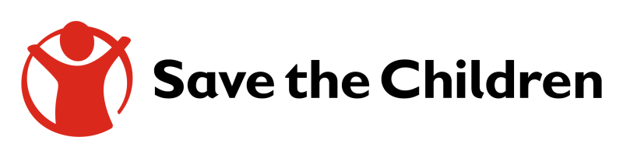

TOR – Photography/Videography Services

Guidelines:
Save the Children (SC) is seeking the services of a media production company to produce a short documentary on the hunger situation in Sudan in two samples location: Tawila in North Darfur and Tokar in Red Sea state. In each location one family who has faced hunger and has been supported by Save the Children shall be filmed for a short, engaging documentary. The produced materials will be used for SC advocacy and communication purposes.

All products conform to the Save the Children branding standard and technical guidelines.

Scope of Work - Project Process:
The supplier will be expected to deliver all of the following as required during the duration of the
contract:
- Production of Content (please see further documents for detailed guidance)
(1) Photographs –-> 20 - 30 photographs
(2) Documentary short, edited version 10-15 minutes a) original language clean version,
b) English subtitled c) all raw materials

- The work scope includes: pre-production, production, SCI consent forms correctly filled, post-production, incl. editing, grading, audio mix, export, provision of editing project file according to SCI technical standards and guidelines. All videos produced must be of the highest quality to adequately represent the organization. This concerns especially the audio recording as well as the image. Sufficient recording of B-roll footage and sound atmospheres is essential.
- The supplier is responsible for securing the appropriate filming permissions. SCI can support this process with a letter etc.
- The supplier shall use their own video camera and professional editing software (minimum standard HD);
- Film the activities and interviews as per the guidance of the SCI focal person.
- Ensure that an informed consent is acquired and the forms are filled according to SCI requirements for all persons depicted in the video, including each child (apart from large groups filmed from a distance).
- Edit the footage in line with the script agreed and approved by the SCI focal person.
- Edit interviews with guidance from relevant SCI focal person.
- Embed English subtitles for interviews and provide clean version without subtitles as well.
- Mix the audio in the final product export into formats for use on TV and the internet;
- Clearly identify location, name and age of interviewees, quotes and any relevant details;
- Include appropriate SCI branding as per the Save the Children instructions and SCI brand guidelines.

- Ensure that all child safeguarding requirements are met (details will be explained by SCI focal person).

DELIVERABLES
Key deliverables are quality products as per the detailed guidelines/budget:

The Production of (please see further documents for detailed guidance):
(1) Photographs –-> 20-30 photographs
(2) Documentary short, edited version 10-15 minutes a) original language clean version,
b) English subtitled c) All raw materials – All raw materials shall be usable for SCI in the future
(3) Correctly filled consent forms for every person, including all children, depicted in the
documentary and in the photos. All children need to be stated by name in the consent
form.
(4) Music rights cleared and documented

The production will involve, but will not be limited to:
- Creation of the general concept of the videos as per the discussion with SCI Communications team.
- Development of the detailed scenarios of the videos;
- Coordination and approval of the scenarios with SCI Communications team.
- Filming of the short documentary
- Post-production/Editing: (editing, sound editing, visual elements such as text, subtitle, logos, music rights clearance and other artworks per Save the Children instructions and SCI brand guidelines.
- Delivery of the photographs, and two final videos in different formats no later than February 20th 2021

TRAVEL AND ACCOMODATION
- Save the Children in Sudan will cover the following until a maximum budget of 4000 USD:
  - Roundtrip traveling costs from Khartoum - El Fasher - Khartoum, Khartoum - Port Sudan - Khartoum
  - Accommodation in the shooting locations
  - Transport in North Darfur / Red Sea states (car rental etc.)
SPECIAL TERMS AND CONDITIONS
- All work meets the highest professional standards.
- Save the Children’s Standard terms and conditions for procurement of services shall apply to contract entered into with you.
- The quotation must include a declaration by yourself to the effect that: I, ____________________________(name), hereby certify that this quotation is a bona fide offer, intended to be the fairest, and that I have not fixed or adjusted the amount of the offer in accordance with any agreement or arrangement with any other person.
- Save the Children reserves the right to accept or reject any quotations in whole or in part and is not bound to give reasons for its decision.

Mode of submission: Quotations to be submitted via email to: omer.sharfy@savethechildren.org

Final content to be signed-off by Advocacy Campaigns and Media and the team.

